
WEEK 4 TASK
Customer Segmentation Using Unsupervised Learning

Name: Manahil Zahra .
Internship: AI/ML Internship
Week: Week 4
Date: 24th july 2026

Table of Contents

1.Introduction

2.Objective

3.Dataset Information

4.Tools and Technologies

5.Libraries Used

6.Methodology

7.Data Preprocessing

8.Feature Scaling

9.K-Means Clustering

10.Elbow Method

11.Silhouette Score

12.Cluster Profiling

13.Heatmap Analysis

14.Cluster Interpretation

15.Hierarchical Clustering

16.Dendrogram

17.Comparison between K-Means and Hierarchical Clustering

18.Results

19.Business Applications

20.Challenges Faced

21.Learning Outcomes

22.Conclusion

23.References

1. Introduction

Machine Learning is divided into three major categories: Supervised Learning, Unsupervised Learning, and Reinforcement Learning.

This project focuses on Unsupervised Learning, where the dataset does not contain any target or output variable. Instead of predicting values, the objective is to discover hidden structures and natural groups within the data.

Customer segmentation is one of the most common applications of Unsupervised Learning in the banking and finance industry. Banks use customer segmentation to understand customer behavior, improve marketing strategies, detect risky customers, and provide personalized financial services.

In this project, two clustering algorithms—K-Means Clustering and Hierarchical Clustering—were applied to group customers with similar credit card usage patterns.

2. Objective

The objectives of this project are:

Understand the concept of Unsupervised Learning.

Perform customer segmentation using clustering algorithms.

Clean and preprocess the dataset.

Handle missing values.

Apply feature scaling using StandardScaler.

Determine the optimal number of clusters.

Implement K-Means Clustering.

Evaluate clusters using Elbow Method and Silhouette Score.

Apply Hierarchical Clustering.

Compare both clustering techniques.

Interpret the clusters from a business perspective.

3. Dataset Information

The dataset contains approximately 8,950 customer records collected over six months.Each row represents a unique credit card customer, while each column describes a specific aspect of customer behavior.

Important features include:

Balance

Purchase Amount

Purchase Frequency

Credit Limit

Cash Advance

Minimum Payments

Payment Amount

Full Payment Percentage

Number of Transactions

Tenure

The CUST_ID column was removed because it is only an identifier and does not contribute to clustering.

4. Tools and Technologies

The project was developed using:

Google Colab

Python

GitHub

5. Libraries Used

The following Python libraries were used:

Pandas

NumPy

Matplotlib

Seaborn

Scikit-learn

SciPy

These libraries were used for data analysis, visualization, preprocessing, clustering, and evaluation.

6. Methodology

The project followed the following workflow:

Import libraries

Load dataset

Explore data

Remove unnecessary columns

Handle missing values

Scale data

Apply K-Means

Plot Elbow Curve

Calculate Silhouette Score

Create final clusters

Generate Heatmap

Apply Hierarchical Clustering

Plot Dendrogram

Compare both algorithms

Interpret results

7. Data Preprocessing

Data preprocessing is the most important step in Machine Learning.

The following preprocessing steps were performed:

Dataset Inspection

The dataset shape, column names, and data types were checked to understand its structure.

Removing Identifier

The CUST_ID column was removed because it does not provide useful information for clustering.

Missing Value Handling

The dataset contained missing values in a few numerical columns.

Instead of deleting those rows, missing values were replaced using the mean of each column.

This approach preserved the dataset while reducing information loss.

8. Feature Scaling

Since clustering algorithms are based on distance calculations, all features must be on the same scale.

The StandardScaler technique was applied.

StandardScaler transforms every feature so that:

-Mean = 0

-Standard Deviation = 1

Without scaling, features with larger values (such as Credit Limit) would dominate the clustering process.

9. K-Means Clustering

K-Means Clustering is an iterative clustering algorithm.

The algorithm works by:

Selecting cluster centers.

Assigning customers to the nearest center.

Updating cluster centers.

Repeating the process until convergence.

Different values of K (2–10) were tested.

10. Elbow Method

The Elbow Method was used to determine the optimal number of clusters.

For each value of K, inertia (Within Cluster Sum of Squares) was calculated.

A graph was plotted between K and inertia.

The point where the graph bends sharply represents the optimal number of clusters.

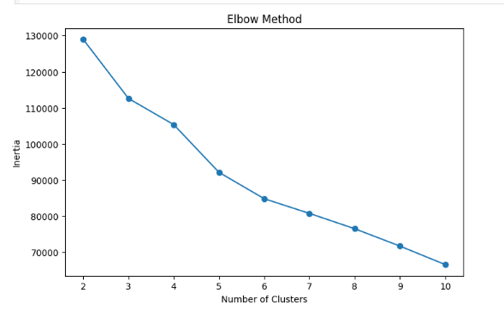

11. Silhouette Score

The Silhouette Score measures cluster quality.

Its value ranges from -1 to 1.

Higher values indicate better-separated clusters.

Silhouette Scores were calculated for every value of K and compared with the Elbow Method.

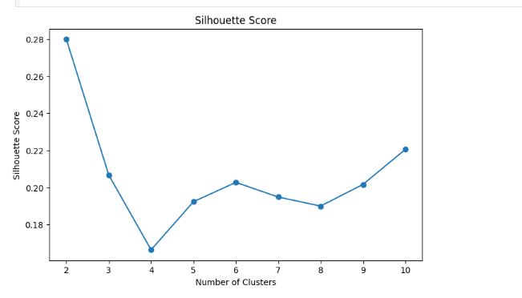

12. Cluster Profiling

After selecting the optimal number of clusters, the average value of every feature was calculated for each cluster.

This helped understand the characteristics of each customer group.

13. Heatmap Analysis

A heatmap was created using Seaborn.

The heatmap visually compared all clusters based on average feature values.

Different colors highlighted similarities and differences among customer groups.

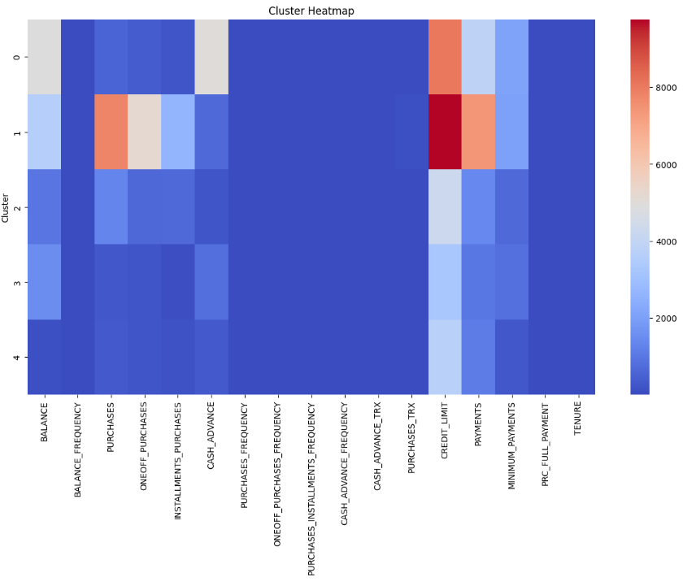

14. Cluster Interpretation

The clusters were interpreted as:

Cluster 0

Medium spending customers with average balances.

Cluster 1

Customers with high balances and high credit limits.

Cluster 2

Customers with low balances and low purchasing activity.

Cluster 3

Customers with frequent purchases and regular payments.

Cluster 4

Customers who frequently use cash advances.

These interpretations help businesses create targeted marketing campaigns.

15. Hierarchical Clustering

Agglomerative Hierarchical Clustering was applied to a random sample of 300 customers.

Unlike K-Means, Hierarchical Clustering creates a tree-like structure showing how clusters are formed.

16. Dendrogram

The dendrogram visually represents cluster formation.

A horizontal threshold line was added to determine the optimal cut for forming clusters.

This visualization helps understand customer relationships.

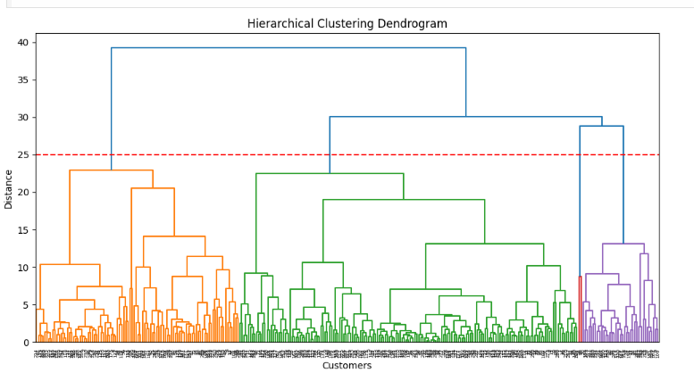

17. Comparison of Algorithms

K-Means

Hierarchical Clustering

Faster

Slower

Suitable for large datasets

Better for small datasets

Easy to implement

Easy to visualize

Computationally efficient

Computationally expensive

Produces stable clusters

Provides hierarchical relationships

For large datasets, K-Means is generally more suitable because it is faster and scales better.

18. Results

The project successfully:

Cleaned the dataset.

Removed missing values.

Standardized all features.

Identified the optimal number of clusters.

Generated customer segments.

Created Elbow Curve.

Calculated Silhouette Scores.

Generated Heatmap.

Created Dendrogram.

Compared both clustering algorithms.

19. Business Applications

Customer segmentation can be used for:

Personalized marketing

Credit risk analysis

Customer retention

Product recommendation

Loyalty programs

Fraud detection

Financial planning

Customer relationship management

20. Challenges Faced

During this project, the following challenges were encountered:

Loading the dataset correctly.

Handling missing values.

Selecting the optimal number of clusters.

Understanding the Elbow Method.

Interpreting heatmaps and dendrograms.

These challenges were resolved through preprocessing and proper visualization.

21. Learning Outcomes

After completing this project, the following concepts were learned:

Unsupervised Learning

Data Cleaning

Feature Scaling

K-Means Clustering

Hierarchical Clustering

Elbow Method

Silhouette Score

Heatmaps

Dendrograms

Customer Segmentation

22. Conclusion

This project successfully demonstrated the application of Unsupervised Machine Learning for customer segmentation.

Both K-Means and Hierarchical Clustering identified meaningful customer groups based on their financial behavior. K-Means was found to be more efficient for larger datasets, while Hierarchical Clustering provided a better visual understanding of relationships between customers.

The generated customer segments can help businesses improve marketing strategies, customer retention, and financial decision-making.
— End of Documentation —

